**Reconfigurable Convolutional Kernels for Neural Networks on FPGAs**

1. Contributions
   1. proposes a run-time reconfigurable CNN kernel architecture based on generic LUT-based constant multiplication.
   2. an automated and flexible tool flow.
2. Generic LUT-based constant multiplication

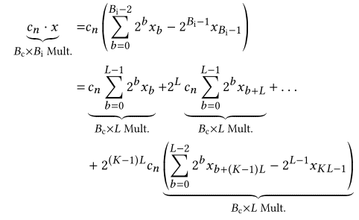

Split the constant multiplication into several smaller multiplications, each computing one partial product.

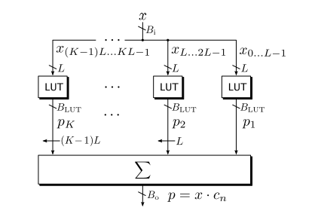

Generic LUT-based constant multiplier

1. Reconfigurable SOP based on CFGLUTs
   1. LUT-based SOP Architecture

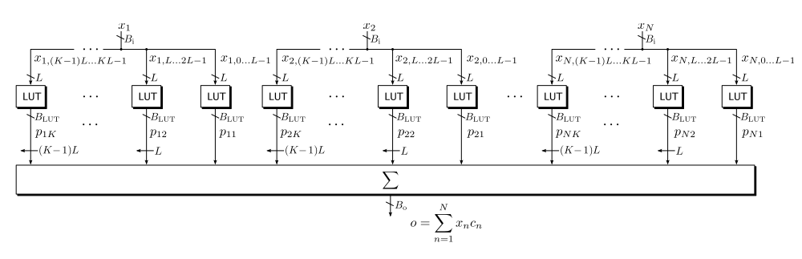

* 1. Faithfully Rounded SOP

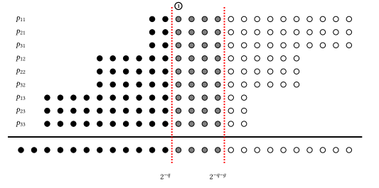

It has the same error bound as truncation but does not necessarily lead to the same output vectors.

* 1. Online Computation of LUT Contents

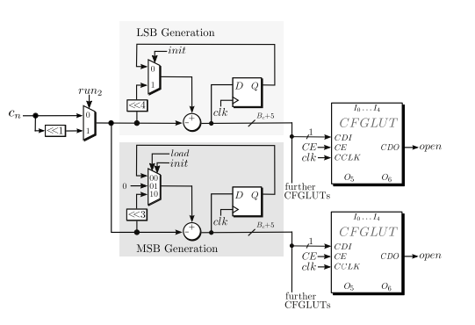

* 1. Using Shadow LUTs to Hide the Reconfiguration Time which similar to the double buffering

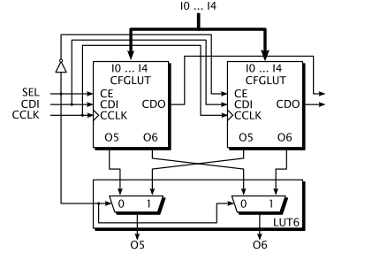

1. Results

…